Application

How Easy Is It To Apply Protection?
All you need is a 2KW+ Hot Air Gun or gas blowtorch, and a foam roller if you’re applying to square posts.
Stapler + Knife required for Wrap & Tack.
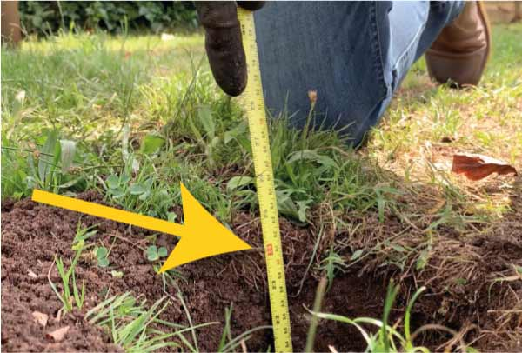
1. Measure Hole Depth
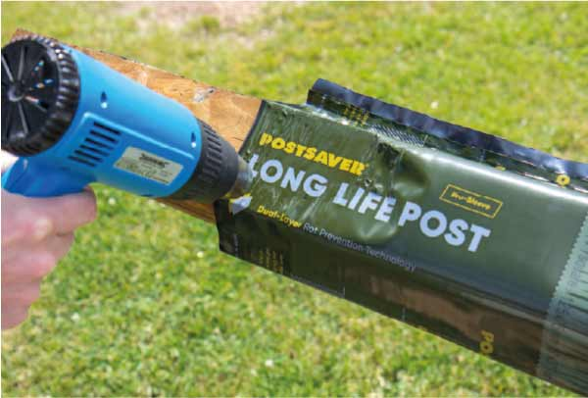
2. Position on the post & heat shrink on
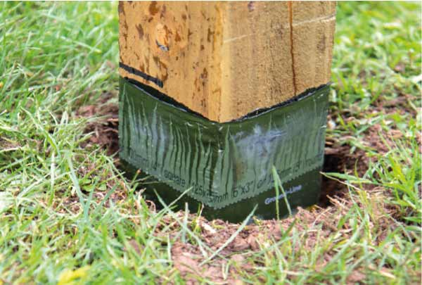
3. Install the post in all the normal ways

Which Type Of Rot Protection Do I Need?
Postsaver protection is available in two types for different applications.
All variations use the same, proven and tested dual-layer technology that is guaranteed for 20 years
Pro-Wrap
For Standard Sized Posts & Gateposts
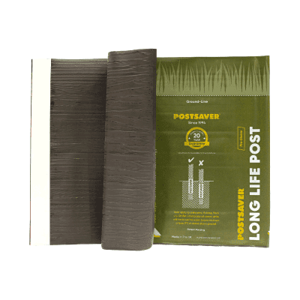
Pro-Wrap's Fit:

3 x 3” - 8 x 8” Square

3” - 10” Round
Available in three handy sizes for standard post sizes, Pro-Wraps wrap around the post and stick to themselves with a self adhesive strip to form a sleeve
Pro-Wrap & Tack
For Odd Sized Posts & Sleeper Protection
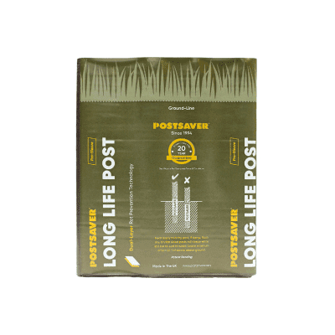
Pro-Wrap & Tack Fits:
All Post Sizes
All Post Sizes
Pro-Wrap & Tack is ideal for odd sized posts and sleepers. Supplied in a 5 metre roll you simply wrap, cut and staple in place to fit any post size or wooden sleepers

Apply Yourself Or Buy Posts With Protection Pre-Applied
Delivered straight to your door, ready for installation

